(Lesson Plan Summary)  KEY VOCABULARY MATERIALS & EQUIPMENT  - Gravity - Atmospheric Pressure & Composition - Surface Temperature & Composition - Rotational Axis, Speed, & Direction REQUIRED (OPTIONAL)  Fact Sheets on Planets (1 copy of each for each group of 3)  https://nssdc.gsfc.nasa.gov/planetary/factsheet/planet_table_ratio.html  https://drive.google.com/file/d/1wowo1uGhy8EmnavEtLDPT_h6Wy7_82z_/view?usp=sharing  PowerPoint Presentation if you have access to a projector, so the students can see more images of the planets as they learn about their different features  Paper and art supplies for drawing/coloring a sketch of their imaginary planet skate park.  Books about space | LEARNING OBJECTIVES / OUTCOMES  - Students will gain knowledge about several features of each of the planets in our solar system, all of which would have an impact on their decision of whether they would build a skate park there.  - Students will exercise their imaginations by creating their own idea of a perfect planet to build a skatepark on.  - Students will expand their vocabulary.  LESSON PREPARATION  - Instructor should have a look over the Planet Fact Sheet and/or PowerPoint presentation to be able to introduce and explain the basics about the different aspects of each planet to the students.  - “Space” stations can be set up ahead of time for the closing activity. Have art supplies and a large piece of paper out at each station where groups of 3 can work together.  ASSESSMENT  - Students create their own imaginary planet skate park and are able to label the various aspects of their planet with explanations of why they decided those were the best conditions for a skatepark in a final small group presentation.
LESSON 1:
INTRODUCTION
20 Min | - Instructor explains to the class that they’ll be creating their own imaginary planet and skatepark today after learning a bit more about the different aspects of the planets in our solar system.  - Divide class into groups of 3 and have students sit at their own “space” stations.  - Distribute fact sheets to each small group | - Students listen and take notes or highlight sections on their fact sheets that they would like to use to create their own planet and skate park. | Printed copies of the planetary fact sheets for each group of 3  https://nssdc.gsfc.nasa.gov/planetary/factsheet/planet_table_ratio.html  https://drive.google.com/file/d/1wowo1uGhy8EmnavEtLDPT_h6Wy7_82z_/view?usp=sharing  Projector (optional) | 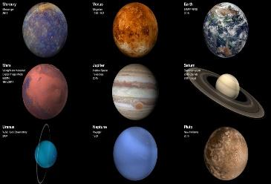
ACTIVITY SEQUENCE
25 Min | - Instructor walks around and answers any questions the small groups have as they are working. | - Students work on drawing and labeling their imaginary planet skate parks using the fact sheets and any books about our solar system that you may have available at your school. | Books about Space  Art supplies  Large sheet of paper for each group of 3 | 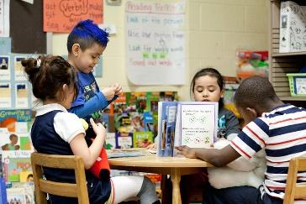
CLOSURE
15 Min | Instructor leads a small discussion at the end of the small group presentations | Student-led small group presentations:  - Short Q & A after each presentation  Closing discussion about the presentations:  - Which planet would be the most fun to skate on?  - Which would be the most realistic?  - What do you think about the conditions of our planet for skating? | Image created by the small groups to present to the class. | 